use final_sql;

select * from final_sql.sql_file_1;

select * from final_sql.sql_file_2;

-- KPI 1 Number of Patients across various summaries

select

sum(`No of pt inc in the transfusion summary`) as Transfusion_Summary,

sum(`No of pt in hypercalcemia summary`) as Hypercalcemia_Summary,

sum(`No of pt in Serum phosphorus summary`) as Serumphosphorus_summary,

sum(`No of pt inc in hospitalization summary`) as Hospitalization_summary,

sum(`No of hplizations inc in hp readmission summary`) as Readmission_summary,

sum(`No of Pt inc in survival summary`) as Survival_summary,

sum(`No of Pt inc in fistula summary`) as Fistula_summary,

sum(`No of pt in long term catheter summary`) as catheter_summary,

sum(`Number of patients in nPCR summary`) as nPCR_summary from final_sql.sql_file_1;

KPI 1 OUTPUT:

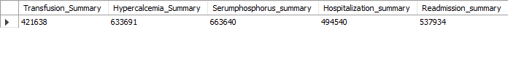

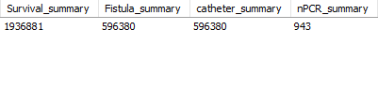

-- KPI 2 Profit Vs Non-Profit Stats

SELECT `Profit or Non-Profit`,

SUM(CASE WHEN `Profit or Non-Profit` = 'profit' THEN 1 ELSE 0 END) as profit,

SUM(CASE WHEN `Profit or Non-Profit` = 'non-profit' THEN 1 ELSE 0 END) as Non_profit

FROM final_sql.sql_file_1

GROUP BY `Profit or Non-Profit`;

KPI2 OUTPUT:

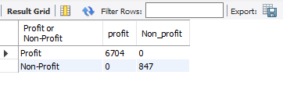

-- KPI 3 Chain Organizations w.r.t. Total Performance Score as No Score (No socore As 0)

SELECT f1.`Chain Organization`,

count(f2.`Total Performance Score`) as 'Total_No_Score'

from sql_file_1 as f1 join sql_file_2 as f2 on

f1.`Facility Name`= f2.`Facility Name`

where`Total Performance Score` = 0

group by f1.`Chain Organization`

order by Total_No_Score desc

limit 10;

KPI 3 OUTPUT:

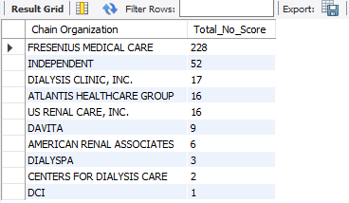

-- KPI 4 Dialysis Stations Stats

SELECT count(`# of Dialysis Stations`), `State`

FROM final_sql.sql_file_1

GROUP BY `State`

order by count(`# of Dialysis Stations`) desc

limit 10;

KPI 4 OUTPUT:

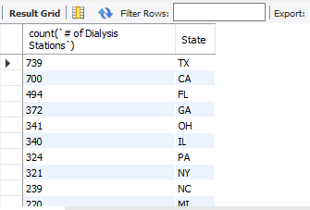

-- KPI 5 # of Category Text - As Expected

SELECT

COUNT(`Patient Transfusion category text`) AS Patient_Transfusion,

COUNT(`Patient hospitalization category text`) AS Patient_hospitalization,

COUNT(`Patient Survival Category Text`) AS Patient_Survival,

COUNT(`Patient Infection category text`) AS Patient_Infection,

COUNT(`Fistula Category Text`) AS Fistula,

COUNT(`SWR category text`) AS SWR,

COUNT(`PPPW category text`) AS PPPW

FROM

final_sql.sql_file_1

WHERE

`Patient Transfusion category text` = 'As Expected'

AND `Patient hospitalization category text` = 'As Expected'

AND `Patient Survival Category Text` = 'As Expected'

AND `Patient Infection category text` = 'As Expected'

AND `Fistula Category Text` = 'As Expected'

AND `SWR category text` = 'As Expected'

AND `PPPW category text` = 'As Expected';

KPI 5 OUTPUT:

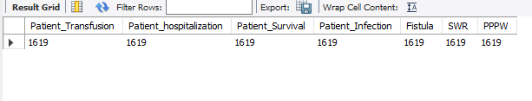

-- KPI 6 Average Payment Reduction Rate

SELECT ROUND(AVG(`PY2020 Payment Reduction Percentage`) * 100, 3)

AS Average_Payment_Reduction_Rate

FROM final_sql.sql_file_2;

KPI 6 OUTPUT:

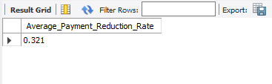

THE END